Comprehensive Project Proposal: InnovestAI
📈 1. Business Concept & Target Users
Real Business Idea
InnovestAI is a retail-focused financial data analytics SaaS platform designed to bridge the gap between complex algorithmic metrics and everyday retail investors. The platform solves the problem of "information overload" by turning volatile live market data streams into clear, digestible, and personalized strategies. It offers institutional-grade data tracking alongside user-managed tracking portfolios augmented with semantic AI models.
Target Users
- The Intermediate Retail Trader: Individuals who actively trade equities or crypto but lack the time or tools to write python parsing scripts, pull data from terminal interfaces, or review lengthy financial disclosures.
- The Concept-Driven Long-Term Investor: Long-term macro-strategy investors who manage custom thematic asset bundles and want to attach strategic, goal-oriented conditions (e.g., "accumulate below target intrinsic calculation") that can be automatically cross-examined by an AI engine based on current market states.

🎨 2. Brand Identity & Visual System
Business Name & Core Identity
- Name: InnovestAI
- Tagline: Clear market vectors. Smarter portfolio paths.
- Tone: Trustworthy, professional, highly technical yet completely accessible, devoid of flashy hyper-speculative gaming jargon.
Brand Palette & Typography
- Primary Navy: #0F172A (Establishes depth and premium security)
- Vibrant Emerald: #10B981 (Represents positive yield and growth analytics)
- Electric Cyan: #06B6D4 (Highlights AI activity metrics and interactive controls)
- Font System: Inter (Clean, highly legible for high-density tabular financial data arrays)
Brand Logo Visual Representation

⚙️ 3. Core Feature Specifications
The application focuses on five deeply integrated features that ensure a continuous data flow between the user interface, backend storage infrastructure, external systems, and semantic processing modules.
Feature 1: Real-Time Cross-Asset Polling Sync
The client platform hooks directly into third-party financial data providers to feed live updates directly to UI components.
- Crypto Layer: Fetches real-time price tickers, daily market caps, and volatility indexes via the public [CoinGecko API](https://www.co gecko.com "CoinGecko API").
- Stock Layer: Polls active equities data streams via Polygon.io or Alpha Vantage.
- Implementation: Handled via local component state intervals combined with structured client-side layout grids to isolate rerendering.
Feature 2: Immutable Session Access Configuration (Auth)
- Secures access control policies through Supabase Auth.
- Restricts custom route access, token parsing, and transactional database requests until the backend decodes a valid JSON Web Token (JWT).
Feature 3: Portfolio Asset Life-Cycle Management (Full CRUD)
Allows complete creation, retrieval, modification, and destruction workflows via relational database tables:
- Create (POST): Instantiates a target asset asset vector inside the operational user context layout.
- Read (GET): Pulls active state logs and user selections directly from relational records.
- Update (PUT): Connects user-defined transactional entries or narrative notes to a dedicated table structure.
- Delete (DELETE): Clears target rows safely while utilizing automated structural database cascading behaviors.
Feature 4: Contextual AI Semantic Risk Analyst
- Packages live cross-referenced pricing maps alongside stored user strategy notes.
- Asynchronously routes context-rich prompt bodies to high-performance parsing layers using the official OpenAI Node SDK.
- Outputs structured, actionable thematic responses via clean UI typography.
Feature 5: Interactive Trend Synthesis Engine
- Implements the light Recharts Library directly inside client dashboard modules.
- Renders raw chronological price arrays inside optimized, interactive line charts that display distinct performance attributes upon interactive user mouse hover events.

🗄️ 4. Relational Database Schema Design
The operational platform architecture structures data elements into standard relational entities with strict field types, foreign keys, constraints, and cascading integrity behaviors.
sql
-- 1. Create User Profiles extending Supabase Identity Core
CREATE TABLE public.user_profiles (
id UUID PRIMARY KEY REFERENCES auth.users(id) ON DELETE CASCADE,
display_name VARCHAR(50),
tier VARCHAR(15) DEFAULT 'free' CHECK (tier IN ('free', 'premium')),
updated_at TIMESTAMP WITH TIME ZONE DEFAULT TIMEZONE('utc'::text, NOW()) NOT NULL
);

-- 2. Core Watchlists Identity Structure (Supports CREATE, READ, DELETE)
CREATE TABLE public.watchlists (
id UUID PRIMARY KEY DEFAULT gen_random_uuid(),
user_id UUID NOT NULL REFERENCES public.user_profiles(id) ON DELETE CASCADE,
symbol VARCHAR(10) NOT NULL,
asset_type VARCHAR(10) NOT NULL CHECK (asset_type IN ('crypto', 'stock')),
created_at TIMESTAMP WITH TIME ZONE DEFAULT TIMEZONE('utc'::text, NOW()) NOT NULL,
UNIQUE (user_id, symbol)
);

-- 3. Granular Strategy Notes Mapping (Supports UPDATE / Structural Modifiers)
CREATE TABLE public.asset_notes (
id UUID PRIMARY KEY DEFAULT gen_random_uuid(),
watchlist_id UUID NOT NULL REFERENCES public.watchlists(id) ON DELETE CASCADE,
notes_content TEXT NOT NULL,
updated_at TIMESTAMP WITH TIME ZONE DEFAULT TIMEZONE('utc'::text, NOW()) NOT NULL,
UNIQUE (watchlist_id)
);

Use code with caution.
Schema Relationship Architecture Overview
- auth.users (Supabase Managed Identity Table) 1 ── 1 public.user_profiles
- public.user_profiles 1 ── 🌍 Many public.watchlists (A single user tracks multiple distinct assets)
- public.watchlists 1 ── 1 public.asset_notes (Each tracking entry has exactly one strategy notes log block)

📐 5. Wireframes & Strategic User Flows
UI Interface Layout Inspirations (Dark Mode Systems)
Architectural Page Layout Wireframes
- /auth (Entry Layout): Clean, centered split-card layout block. One side contains the clean minimalist visual brand mark logo, the other exposes email/password input blocks alongside simple contextual state routing buttons.
- /dashboard (Core Market View): Uses a structural three-column grid layout pattern.
  - Top: A marquee horizontal live asset ticker element.
  - Left (Narrow): Sticky routing panel bar links.
  - Center (Wide): Global market overview, current gainers/losers tables, asset search container input element.
  - Right (Standard): Interactive line charts featuring simple temporal granularity buttons (1D, 1W, 1M).
- /portfolio (The User CRUD Panel):
  - Main Content Panel: Active personal asset tracking grid displaying asset cards. Each card displays live pricing parsed from external API networks alongside a structural trash trigger element.
  - Lower Panel Split View: An interactive form container exposing text-area controls for updating strategic notes alongside an "Analyze My Portfolio via AI Agent" interactive call-to-action button.
Operational User Flow Diagram
text
[Landing/Login Screen] ──(Valid Auth Token)──> [Global Market Dashboard View]
│
(Select Asset / Trigger Add)
│
▼
[AI Assistant Result Readout] <──(Run Analyst)── [Personal Portfolio Table Panel]
│
(Modify Strategy Note)
│
▼
[Execute Database UPDATE]

Use code with caution.

⚡ 6. Full-Stack Architecture Proposal
Complete Framework Architecture Stacking
- Client Core Engine Layout Layer: React.js (Vite Environment Setup). Handles declarative template compilation and interactive states.
- Client State Router Logic Config: React Router Dom (v6+ Browser Route Controller engines).
- Application Server Middleware Proxy: Express.js hosted inside an accessible Node.js runtime platform container.
- Database Management System Pool: Managed PostgreSQL instance handled via the cloud infrastructure layers of the Supabase environment.
- Client Style Composition System: Tailwind CSS coupled with simple components to enable rapid UI design and consistent layouts.
Selected Deployment Plan
- Frontend Distribution Strategy: Client build scripts export static assets mapped directly into high-availability Vercel global edge network architectures.
- Backend Server Runtime Deployment: The isolated Express engine is containerized using basic environments and continuously deployed through automated infrastructure platforms like Render or Railway.
Implementation Trade-offs & Structural Decisions
1. Decoupled Express Backend vs. Serverless API Edge Middleware
- Decision Selected: Decoupled Express Server Engine.
- Reasoning Strategy: Utilizing a standalone server gives us fine-grained control over API connection lifecycles when talking to the OpenAI SDK. It avoids cold-start issues common with serverless environments and makes it easier to implement system-wide route rate-limiting later on.
2. Local State Management vs. Global Redux Toolkit Store Configurations
- Decision Selected: React Context Provider Engine + Component Local States.
- Reasoning Strategy: Since our live data flows directly from dedicated individual component fetch operations and user scopes are isolated by authentication layouts, relying on React Context to distribute session details eliminates unnecessary state overhead and keeps the frontend simple.
3. Client Data-Fetching Engine Choice
- Decision Selected: Axios Instance paired with short polling loops.
- Reasoning Strategy: WebSockets provide optimal streaming performance but frequently exceed free-tier usage limits on developer sandboxes. Regular short polling via Axios easily stays within standard API rate limits while keeping server configuration simple.
The user clicks an "Analyze My Portfolio" button. Your React app sends the user's current watchlist data to your Express backend. The backend forwards this data along with a prompt to an AI model (like OpenAI's GPT-4o-mini or Anthropic's Claude), which returns a custom financial breakdown, risk assessment, and market summary.

Here are structural wireframe diagrams for the three main routes. They use a standard UI layout system to map exact layout requirements before begin styling with CSS.
1. /auth (Entry Layout)
A clean, balanced split-card structure centered on the viewport.
text
+-----------------------------------------------------------------------+

| |
| +-------------------------+ |
| | VantageAI | |
| +-------------------------+ |
| | | |
| +-----------------+-------------------------+-----------------+ |
| | | | |
| | [ LOGO ZONE ] | WELCOME BACK | |
| | | | |
| | ⚡ VantageAI Vector | Email | |
| | | [___________] | |
| | "Clear market vectors. | | |
| | Smarter portfolio paths." | Password | |
| | | [___________] | |
| | | | |
| | | ( LOGIN BTN ) | |
| | | | |
| | | Need account? | |
| | | > Sign Up < | |
| | | | |
| +-------------------------------------------+-----------------+ |
| |
+-----------------------------------------------------------------------+

Use code with caution.

2. /dashboard (Core Market View)
A structured 3-column workspace with a fixed top asset marquee ticker.
text
+-----------------------------------------------------------------------+

| [TICKER] BTC $94.2k ▲ 2.1% | ETH $2.9k ▼ 0.4% | AAPL $242 ▲ 1.1% |
+-----------------------------------------------------------------------+

| NAVBAR | CENTER (WIDE) | RIGHT |
| | | |
| [V👁️] | Search Asset: [ Search symbols... ] | MARKET TREND |
| | | |
| (Dash) | +-------------------------------------+ | +------------+ |
| | | GLOBAL MARKET OVERVIEW | | | /\ /\ | |
| (Port) | | Volatility Index: Stable | | | / \ / | |
| | | Fear & Greed: 62 (Greed) | | | / \/ | |
| (Set) | +-------------------------------------+ | +------------+ |
| | | [1D] [1W] [1M] |
| | +-------------------------------------+ | |
| | | TOP GAINERS / LOSERS | | ASSET STATS |
| | | 1. NVDA +4.2% | | Vol: 14.2B |
| | | 2. SOL +3.8% | | PE: 28.4 |
| | | 3. TSLA -2.1% | | |
| | +-------------------------------------+ | |
+----------+-------------------------------------------+----------------+

Use code with caution.

3. /portfolio (The User CRUD Panel)
Your primary interactive user control hub housing your CRUD actions and AI triggers.
text
+-----------------------------------------------------------------------+

| [TICKER] BTC $94.2k ▲ 2.1% | ETH $2.9k ▼ 0.4% | AAPL $242 ▲ 1.1% |
+-----------------------------------------------------------------------+

| NAVBAR | MAIN PORTFOLIO CONTENT PANEL |
| | |
| [V👁️] | +------------------+ +------------------+ +-----------+ |
| | | BTC - Bitcoin | | AAPL - Apple | | ( + ADD ) | |
| (Dash) | | $94,210.00 | | $242.15 | | | |
| | | ▲ 2.1% | | ▲ 1.1% | | New Asset | |
| (Port) | | [🗑️ Delete] | | [🗑️ Delete] | | | |
| | +------------------+ +------------------+ +-----------+ |
| (Set) | |
| | +--------------------------------------------------------+ |
| | | LOWER PANEL SPLIT VIEW: STRATEGY & AI INSIGHTS | |
| | | | |
| | | Selected Asset Strategy Notes (UPDATE): | |
| | | [ Accumulate more BTC if pricing drops below $90k... ]| |
| | | [ (SAVE NOTES CHANGED) ] | |
| | | | |
| | | 🤖 AI Portfolio Analysis | |
| | | ( ANALYZE PORTFOLIO WITH VANTAGEAI AGENT ) | |
| | +--------------------------------------------------------+ |
+----------+------------------------------------------------------------+

Use code with caution.
Layout Implementation Guidelines
- Responsive Breakpoints: On screens under 1024px wide, use a standard single-column stack layout instead of the 3-column system to keep tables readable.
- Component Reusability: Build the [TICKER] as a global layout component wrapped inside your React Router Layout structure. This ensures it stays rendered across routes without unmounting and fetching data repeatedly.
Should we move on to generating the clean HTML/Tailwind skeleton layout structures based on these wireframes, or would you like to build out the Express.js route handling logic next?
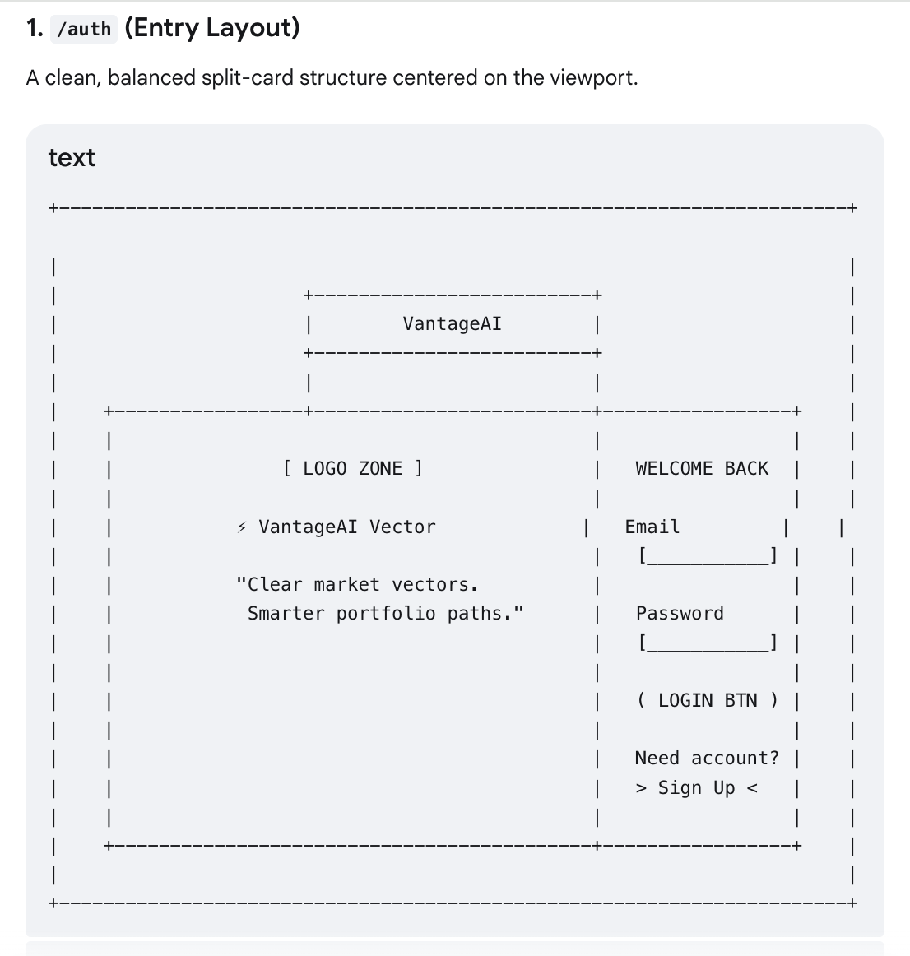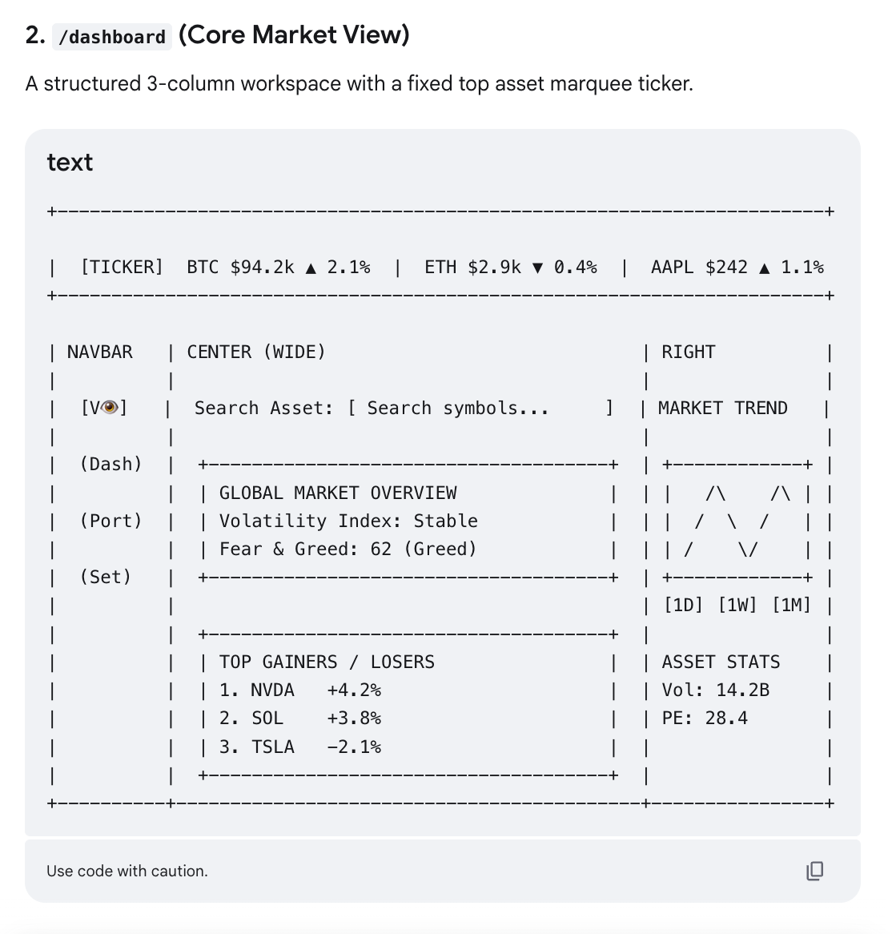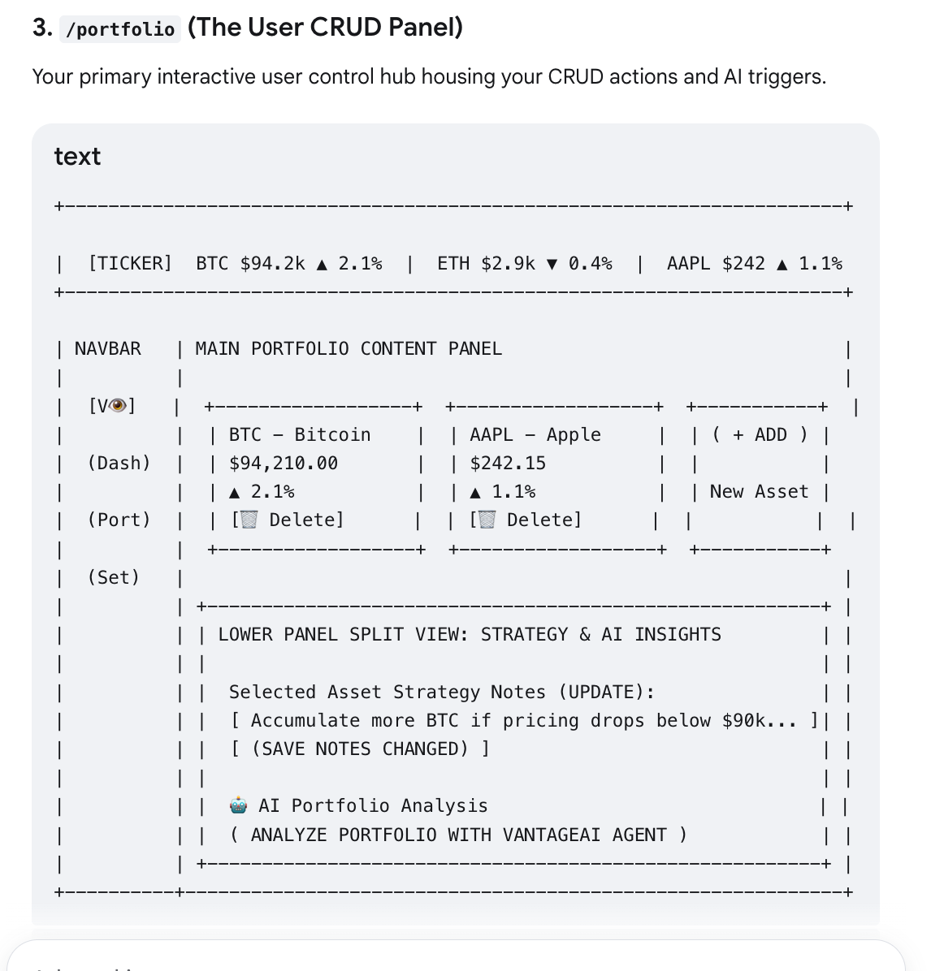

-- 1. Create User Profiles extending Supabase Identity Core
CREATE TABLE public.capstone_user_profiles (
id UUID PRIMARY KEY REFERENCES auth.users(id) ON DELETE CASCADE,
display_name VARCHAR(50),
tier VARCHAR(15) DEFAULT 'free' CHECK (tier IN ('free', 'premium')),
updated_at TIMESTAMP WITH TIME ZONE DEFAULT TIMEZONE('utc'::text, NOW()) NOT NULL
);

-- 2. Core Watchlists Identity Structure (Supports CREATE, READ, DELETE)
CREATE TABLE public.capstone_watchlists (
id UUID PRIMARY KEY DEFAULT gen_random_uuid(),
user_id UUID NOT NULL REFERENCES public.capstone_user_profiles(id) ON DELETE CASCADE,
symbol VARCHAR(10) NOT NULL,
asset_type VARCHAR(10) NOT NULL CHECK (asset_type IN ('crypto', 'stock')),
created_at TIMESTAMP WITH TIME ZONE DEFAULT TIMEZONE('utc'::text, NOW()) NOT NULL,
UNIQUE (user_id, symbol)
);

-- 3. Granular Strategy Notes Mapping (Supports UPDATE / Structural Modifiers)
CREATE TABLE public.capstone_asset_notes (
id UUID PRIMARY KEY DEFAULT gen_random_uuid(),
watchlist_id UUID NOT NULL REFERENCES public.capstone_watchlists(id) ON DELETE CASCADE,
notes_content TEXT NOT NULL,
updated_at TIMESTAMP WITH TIME ZONE DEFAULT TIMEZONE('utc'::text, NOW()) NOT NULL,
UNIQUE (watchlist_id)
);

